|  |  |
| --- | --- |
|  | |
|  |  |
|  | |

|  |  |
| --- | --- |
| 41 North Rio Grande Street, Suite 106 Salt Lake City, UT 84101 801.736.4100 **www.rsginc.com** |  |
| **prepared for:** |
| Utah Department of Transportation |
| **Submitted By:** |
| rsg |
|  |
|  |
|  |

1.0 Buffer Time Index 5

1.1 | Methodology 5

Performance Monitoring System Data 5

Existing Conditions BTI Calculations 7

Correlating BTI to V/C 9

Travel Model Application 12

1.2 | Results 12

**List of Figures**

Figure 1: BTI Equation 4

Figure 2: Sample 15-Minute speed Data at Southbound I-15 in Sandy 5

Figure 3: Speed vs. Flow at SOUTHBOUND I-15 in Sandy 5

Figure 4: Speed vs. Density at SOUTHBOUND I-15 in Sandy 6

Figure 5: Flow vs. Density at SOUTHBOUND I-15 in Sandy 6

Figure 6: Percentile Speed by Time of Day at SOUTHBOUND I-15 in Sandy 7

Figure 7: Speed and BTI by time of Day at SOUTHBOUND I-15 in Sandy 8

Figure 8: Sample BTI vs. V/C at SOUTHBOUND I-15 in Sandy 9

Figure 9: Sample BTI vs. Average Speed at SOUTHBOUND I-15 in Sandy 9

Figure 10: BTI vs. V/C FOR ALL 504 DATA POINTS 10

Figure 11: BTI Vs. V/C Data with BTI Model Overlayed 11

Figure 12: 2014 Buffer Time Results 12

Figure 13: 2014 Buffer Time Results (AM) 12

Figure 14: 2014 BUFFER TIME RESULTS (PM) 13

Figure 15: 2014 BUFFER TIME RESULTS (MD) 14

Figure 16: 2014 Buffer Time Results (Free Flow) 15

Figure 17: Buffer Times Between Kaysville and Salt Lake City 16

Figure 18: Buffer Times Between Draper and Salt Lake City 17

Figure 19: Buffer Times Between Lehi and Salt Lake City 18

Figure 20: 2050 Maximum Buffer Times for Select Origins and Destinations 19

# Buffer Time Index

Buffer Time Index (BTI) was chosen as a metric to measure travel time reliability in the WFCCS. BTI is defined as the extra, or “buffer,” time required for a motorist to arrive at a destination on time 95% of the time. This can be interpreted as motorists experiencing a “typical” commute all but one day of the month, assuming approximately 20 working days per month. Figure 1 shows the BTI equation from the Federal Highway Administration.[1] An adaptation of this equation was used to estimate buffer time with the travel model.

Figure : BTI Equation

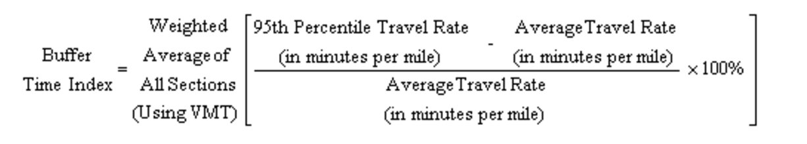

## Methodology

While 95th percentile and average travel rate in minutes per mile can be measured using observed data, it is harder to know what these would be in the future when demand changes. In addition, the travel model only measures average congested travel conditions, not the 95th percentile. An alternate method to estimate BTI was used where BTIs were calculated based on observed data and correlated to volume-to-capacity (V/C) ratio, which can easily be measured in the travel model and related to current and future conditions. This method used speed instead of a travel rate in minutes per mile. This was done because the observed data measured spot location speed and not corridor travel time (i.e. minutes per mile). The fifth percentile speed, which correlates to the 95th percentile travel rate, was used in the calculations.

### Performance Monitoring System Data

Observed data from UDOT’s Performance Monitoring System (PeMS) provided the fifth percentile and average speed data used to calculate existing conditions BTI. Two scripts were developed using Python to download and process the I-15 PeMS data. The first script downloaded the raw text files from the UDOT PeMS website. The raw data were downloaded, by station, for all 12 months in five-minute bins for the year 2014, totaling 12 files for each station.

The second Python script processed and filtered the data. This script iterated through each station, selected the text file for each month, and merged the 12 files into one .csv file. Logic was added to the script to aggregate the data into one-hour bins. Other logic was included in the script to flag stations with only 100% observations. A second flag was added using the date/time to return a value indicating the day of the week. Figure 2 through Figure 5 show a sample of aggregated speed data at one location for several months of the year.

Figure : Sample 15-Minute speed Data at Southbound I-15 in Sandy

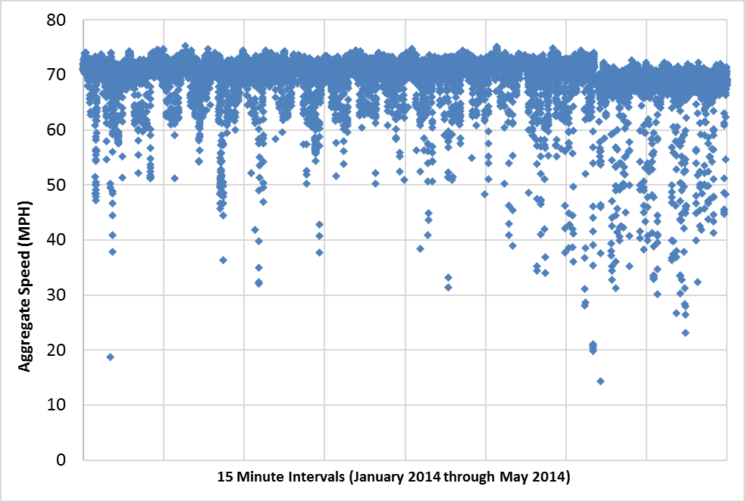

Figure : Speed vs. Flow at SOUTHBOUND I-15 in Sandy

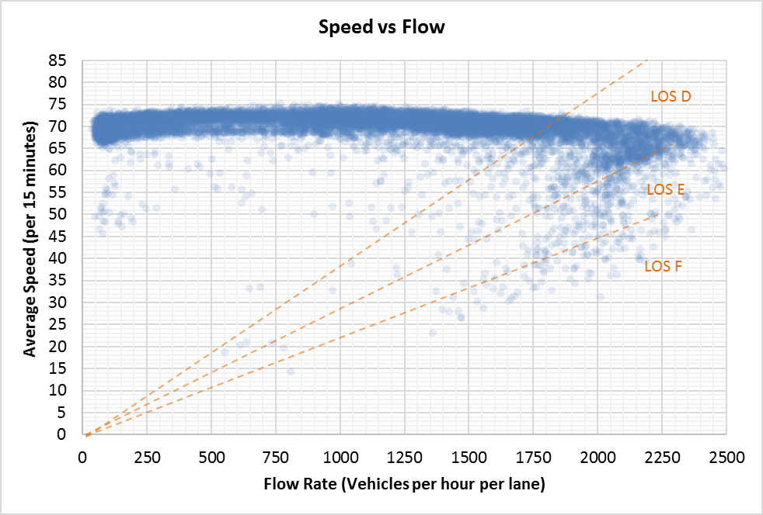

Figure : Speed vs. Density at SOUTHBOUND I-15 in Sandy

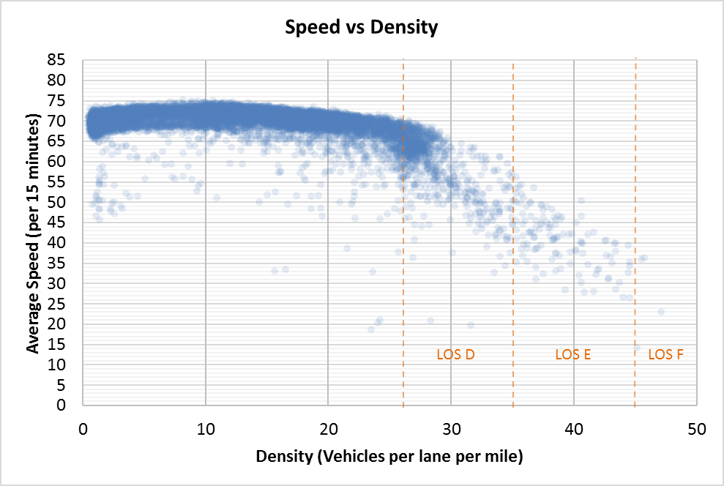

Figure : Flow vs. Density at SOUTHBOUND I-15 in Sandy

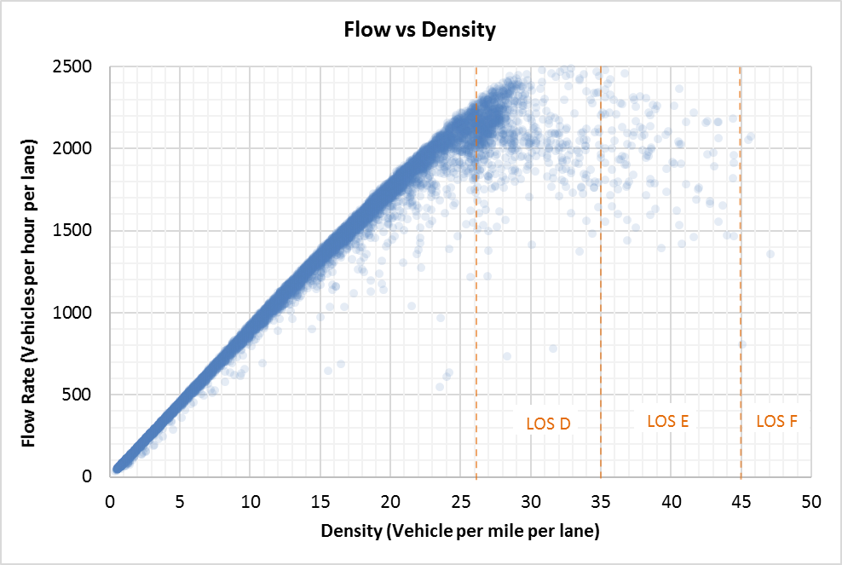

### Existing Conditions BTI Calculations

A random selection of 21 general-purpose freeway PeMS stations were used in the BTI calculations. Locations were chosen using Microsoft Excel’s random number generator. Each PeMS location contained approximately 200 weekday observations for each hour of the day. The combined dataset contained over 100,000 data points (21 locations x 200 weekdays x 24 hours).

The fifth percentile and the average speeds were calculated for each of the 21 PeMS sample. Speeds were calculated independently for each hour using the 200 weekday observations resulting in unique speed profiles for each hour of the day, as seen in Figure 6. The more congested hours of the day have lower speed profiles, including lower average and fifth percentile speeds.

Figure : Percentile Speed by Time of Day at SOUTHBOUND I-15 in Sandy

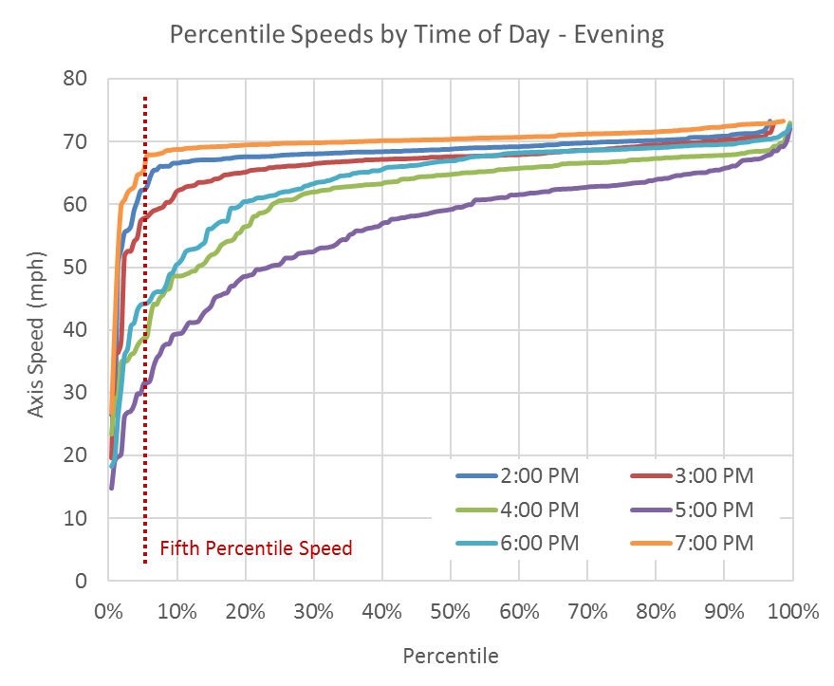

Figure : Speed and BTI by time of Day at SOUTHBOUND I-15 in Sandy

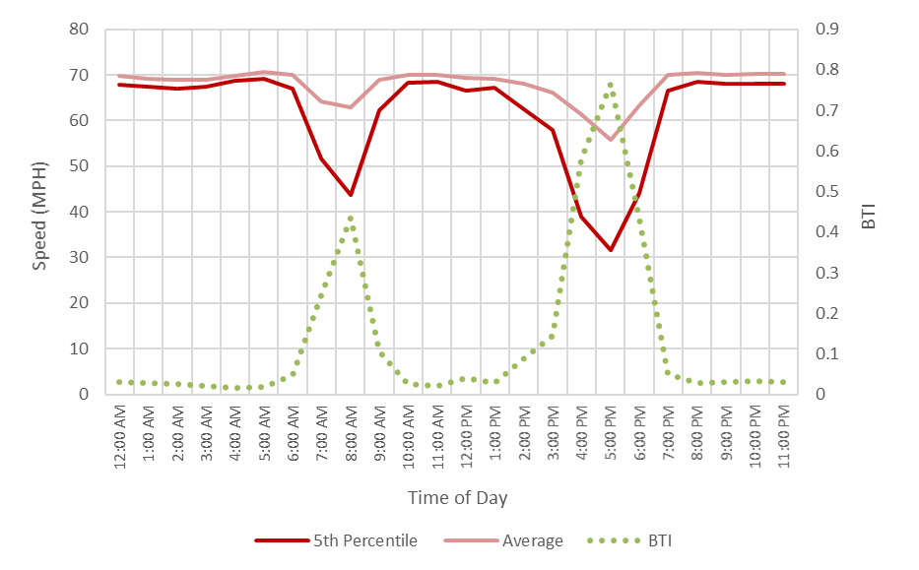

BTIs were calculated for each hour and location resulting in 504 BTI data points (21 locations * 24 hours). BTIs were calculated by subtracting the inverse of the average speed from the inverse of fifth percentile speed and dividing by the inverse of the average speed. Because travel times cannot be calculated directly, the inverse of speed is used to create unit travel times.

Generally, the fifth percentile speeds are nearer the average speeds in less-congested hours. Thus, BTI calculations for less-congested hours yield lower buffer time percentages. In more-congested hours, larger differences between the average and fifth percentile speeds are observed, which results in higher BTI percentages. Larger BTI percentages mean travelers would need to plan more time, in addition to their normal congested commuting time, to account for less reliability due to unforeseen events, such as accidents or inclement weather.

### Correlating BTI to V/C

To correlate BTI to congestion, the volume-to-capacity (V/C) ratio was used. Average hourly volumes were calculated by averaging all flow rates in each given hour across all weekdays in 2014 where data were available from PeMS. The capacity for each PeMS location was estimated based on the general-purpose freeway lane capacity from the travel model multiplied by the number of general-purpose lanes at the PeMS location. For simplicity, the per-lane capacity from the travel model assumed a 65-mph facility with aux lanes. The calculated BTI was then matched to its corresponding V/C ratio.

The following figures show a sample BTI vs. V/C and BTI vs average speed calculations for southbound I-15 near 90th South in Sandy. This data is typical of most of the PeMS data evaluated. It shows consistency with general observations of traffic flow that speed remains reliable until demand approaches capacity, at which point speed and reliability decrease (BTI increases).

Figure : Sample BTI vs. V/C at SOUTHBOUND I-15 in Sandy

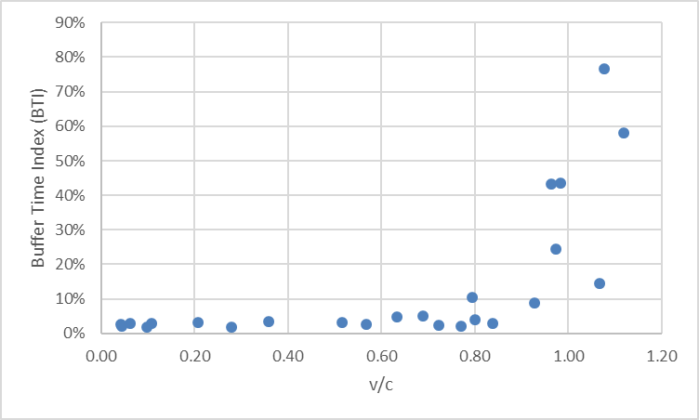

Figure : Sample BTI vs. Average Speed at SOUTHBOUND I-15 in Sandy

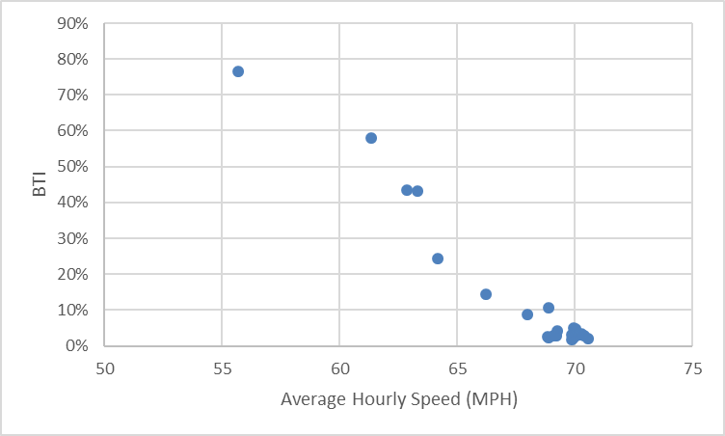

BTI vs. V/C data were reviewed from multiple perspectives: facility type (basic, weave, merge, diverge), the presence of auxiliary lanes, and by the average speed of the locations. No uniquely discernable patterns were detected based on facility type, auxiliary lanes, or average speeds. The data did, however, show a common pattern. The BTI tended to remain low up to a V/C ratio of 0.6 to 0.8, at which point BTI tended to grow rapidly and become more disperse.

Figure : BTI vs. V/C FOR ALL 504 DATA POINTS

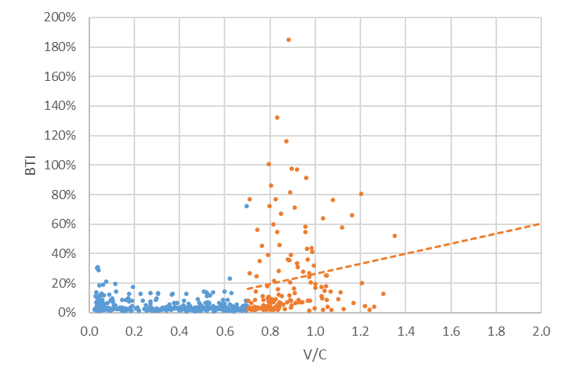

A BTI vs. V/C model was created using the observed data. The model has three phases:

* **Phase 1** covers the area of low congestion with low and more stable BTI values. The observed data for this phase had an average BTI value of 3 to 5% (median=3% and mean=4.9%). A uniform 4% BTI for V/C values less than 0.6 was chosen for Phase 1.
* **Phase 2** covers the area from V/C of 0.6 to 0.8 where the model transitions between the Phase 1 and Phase 3 curves.
* **Phase 3** represents the congested area of the curve where the data is more scattered. This portion covers the area for V/C’s greater than 0.8. The modeled BTI for this range is based on linear regression drawn through the data (see Figure 10).

Figure 11 shows the BTI vs. V/C model overlaid on the observed data.

Figure : BTI Vs. V/C Data with BTI Model Overlayed

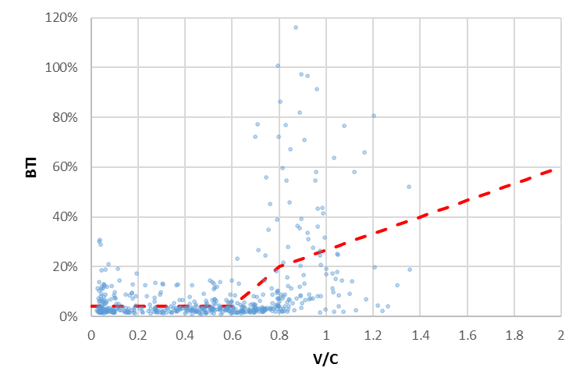

### Travel Model Application

The BTI-V/C model parameters are read into the travel model through a lookup file, “Lookup_BTI.csv,” found in “_Inputs\6_Static\0_SpeedCap\.”

A set of fields, *_BTI_tme (the * representing FF, AM, MD, PM and EV), was added to the final loaded network in the network summary script (“5_AssignHwy\As\04_SummarizeLoadedNetworks.s”). These fields store the amount of buffer time calculated for each link. Buffer times are calculated by multiplying the link’s travel time for each time period by the BTI percent returned from the BTI lookup file and the link’s period specific V/C ratio. Buffer times are calculated only for Managed Motorways freeway lanes and general-purpose freeway lanes (functional types 22–27 and 32–40). All other link functional types have a buffer time of zero. This was done since the data used to estimate the BTI model used only freeway general-purpose lanes.

Zone-to-zone buffer times are calculated in the final loaded network skimming script (“5_AssignHwy\As\ 07_PerformFinalNetSkim.s”). The script traces the buffer time variables as part of the regular general-purpose skim. The total buffer times are included a new table, GP_BTI_Time, in the period-specific matrix files found in the “5_AssignHwy\Ao\” folder.

## Results

Figure 12 through Figure 16 show the results from the buffer time calculations for 2014. Paths through more congested periods tend to result in higher buffer times and appear in line with expectations.

Figure : 2014 Buffer Time Results



Figure : 2014 Buffer Time Results (AM)

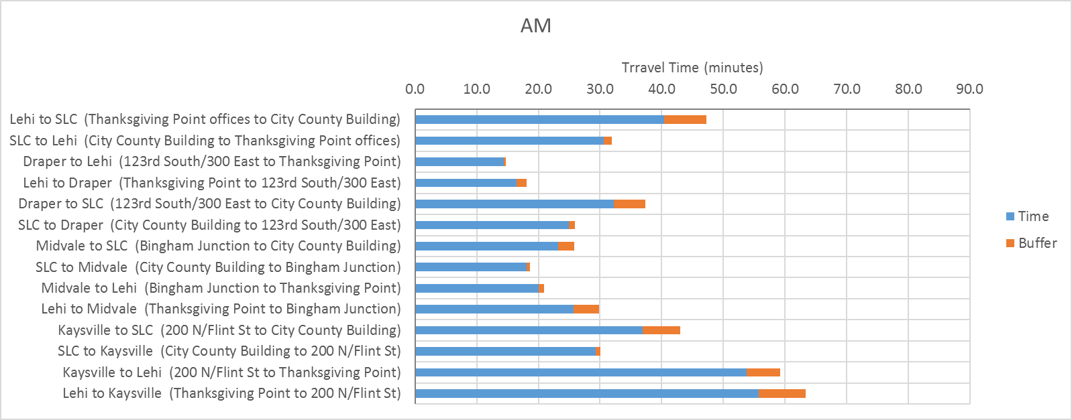

Figure : 2014 BUFFER TIME RESULTS (PM)

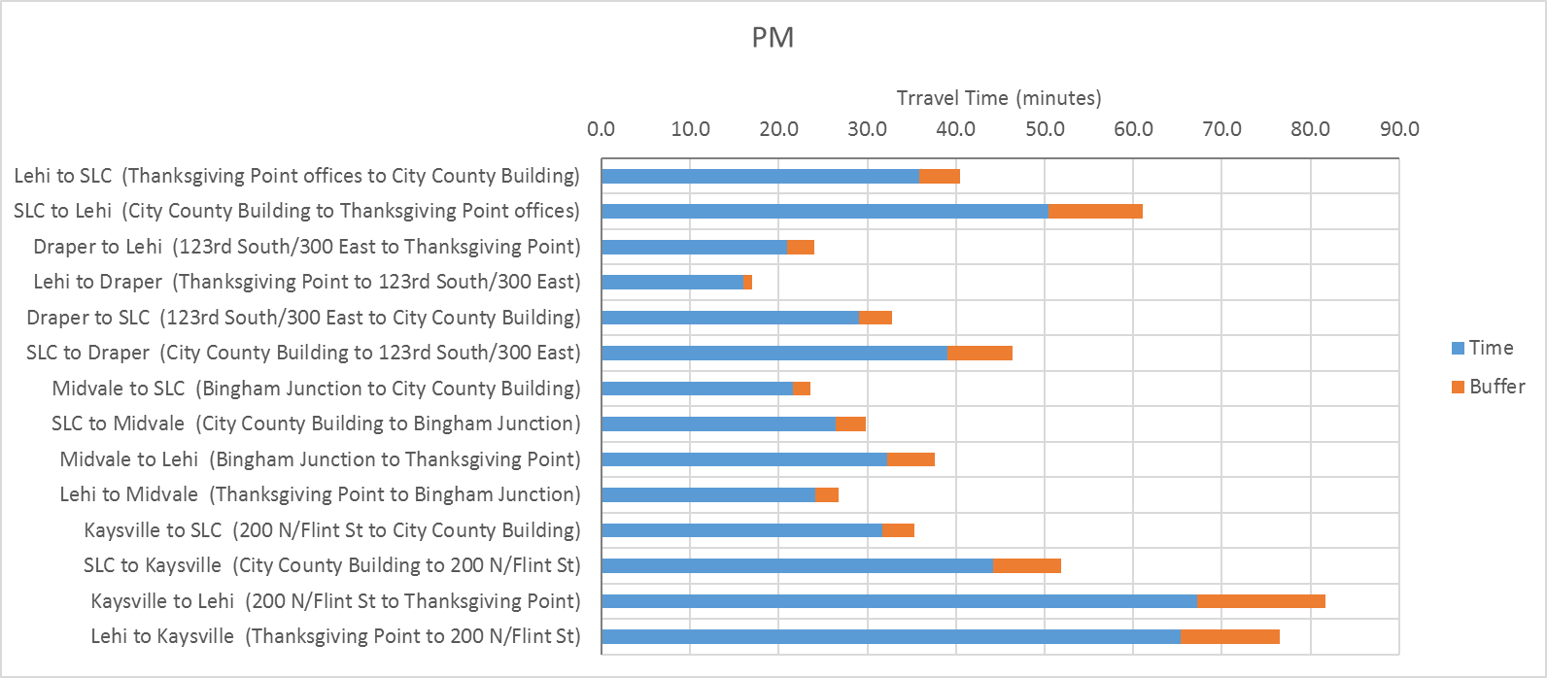

Figure : 2014 BUFFER TIME RESULTS (MD)

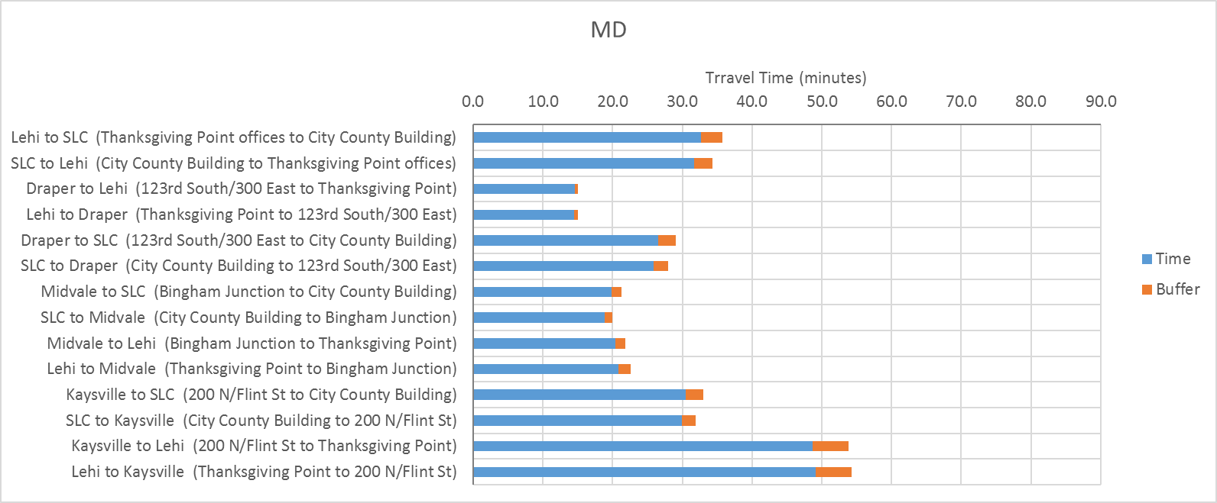

Figure : 2014 Buffer Time Results (Free Flow)

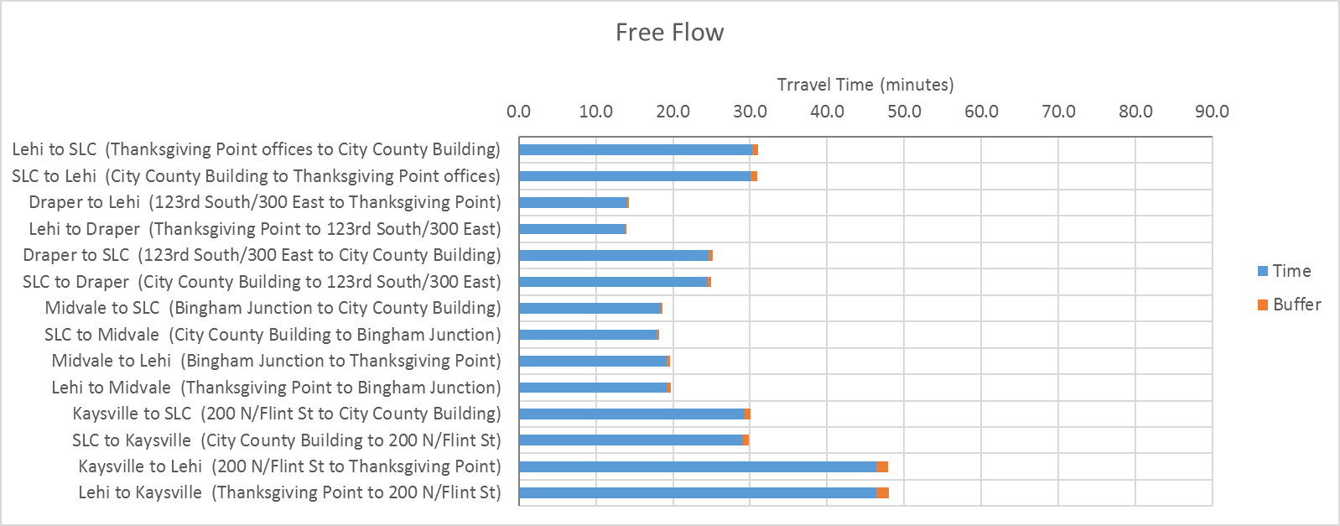

The following figures compare the 2050 results from the buffer time calculations for the WFCCS scenarios for select origins and destinations in the study area. Results are shown for 2050 Base Scenario (S0), 2050 Scenario 1 (S1), 2050 Scenario 2 (S2) and 2050 Scenario 3 (S3). The base year 2014 data are also shown for comparison. Results are stratified by the following time periods:

* AM Peak Period – 6 AM to 9 AM
* Midday (MD) Period – 9 AM to 3 PM
* PM Peak Period – 3 PM to 6 PM
* Free Flow (FF) – represents free flow conditions

Figure : Buffer Times Between Kaysville and Salt Lake City

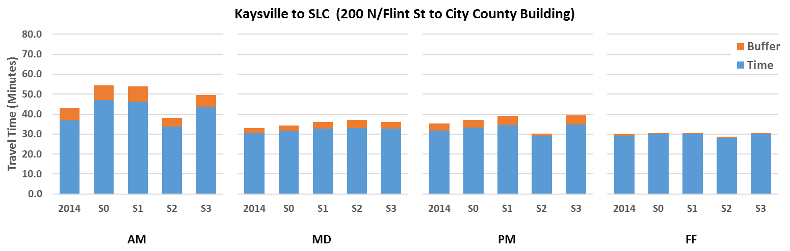

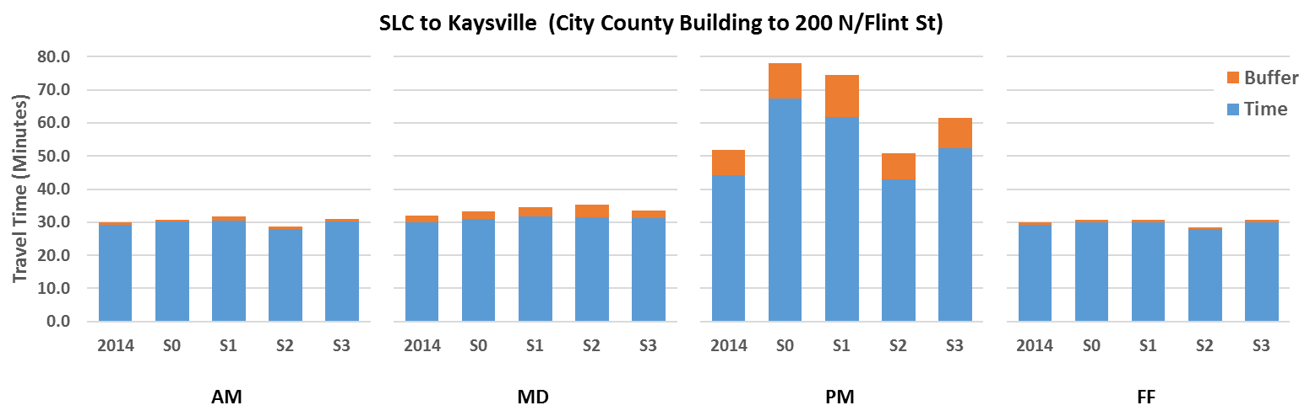

Figure : Buffer Times Between Draper and Salt Lake City

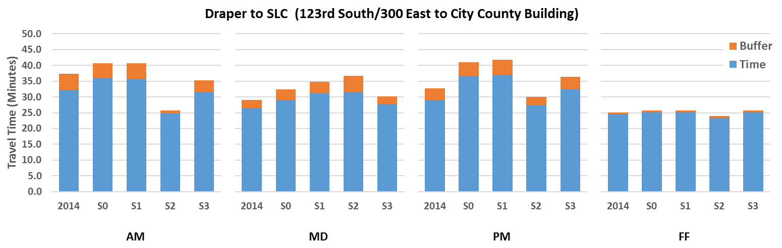

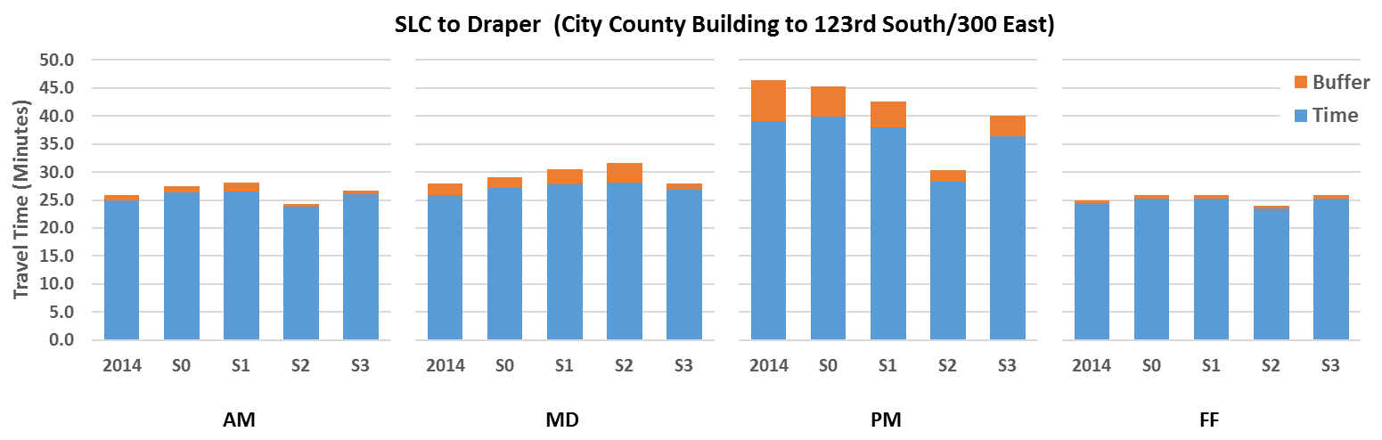

Figure : Buffer Times Between Lehi and Salt Lake City

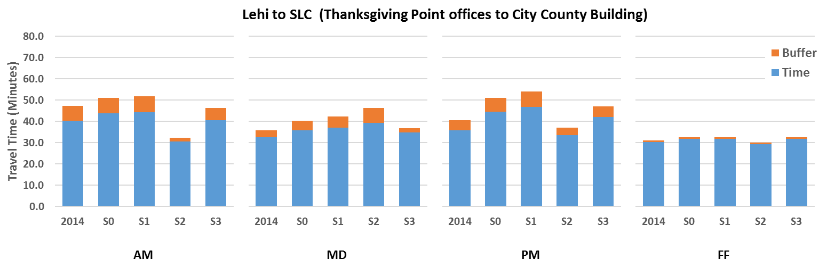

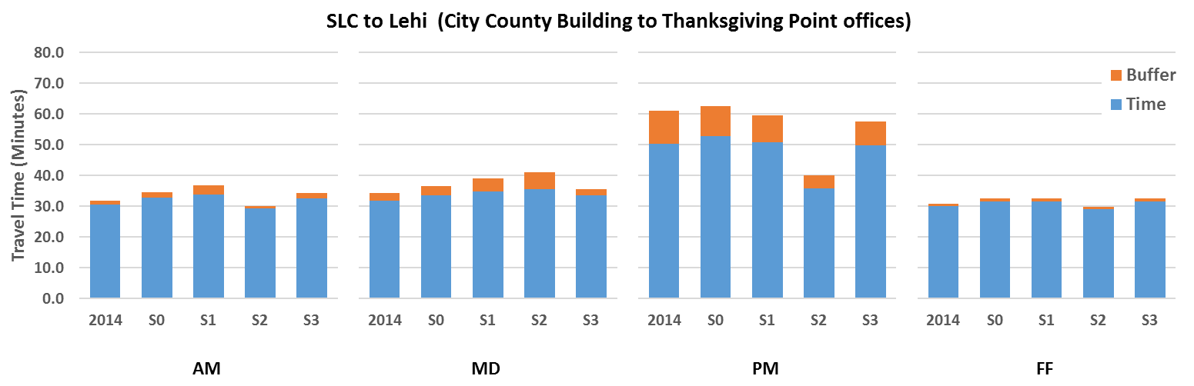

The PM commute between Salt Lake and Davis counties has among the highest calculated buffer times. In general, Scenario 2 has a lower buffer time and Scenario 1 has a higher buffer time, as seen in the following chart.

Figure : 2050 Maximum Buffer Times for Select Origins and Destinations

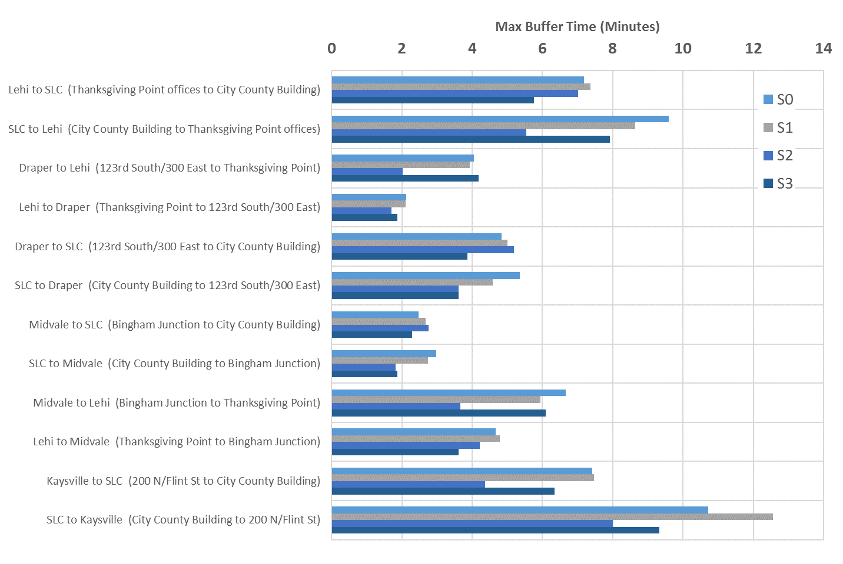

1. BTI equation source: <http://ops.fhwa.dot.gov/congestion_report_04/appendix_C.htm>